

Limiting Carbon Emissions in your Rotary Meetings
Why should we be concerned about our own Carbon Footprint ?
If Rotarians take action we can help reduce Climate Change (introducing a four-step process for use in your Rotary club)
Do your Club meetings cause any carbon emissions ?
(use ESRAG tools to calculate emission levels)
Take action (emission reduction plans and carbon offset strategies)
_______________________________________________________________
Why should we be concerned about our own Carbon Footprint ?
In 2023 we have seen wildfires raging across Southern Europe, North Africa, and USA. Wildfires devastated the island of Maui, Hawaii in August 2023 and as summer approaches more wildfires are predicted in Australia. Top United Nations climate scientists have said it is “virtually certain” that July 2023 will be the warmest for the planet since records have been taken, and it was. UN Secretary-General António Guterres warned in July 2023 that “the era of global warming has ended” and “the era of global boiling has arrived”. He said leaders “must step up for climate action and climate justice”. Australia and New Zealand are ranked in the top 20 countries for greenhouse gas emissions per head of population in the world (Joint Research Centre (2023). "GHG emissions of all world countries". EDGAR - Emissions Database for Global Atmospheric Research. Retrieved 2023-11-01). And within the family of ESRAG Oceania, low lying Pacific Island nations are amongst the countries most likely to be inundated by rising sea levels caused by climate change.
The United Nations’ ‘Intergovernmental Panel on Climate Change (IPCC)’, the global authority on the science of climate change, said “Human activities, principally through emissions of greenhouse gases, have unequivocally caused global warming, with global surface temperatures reaching 1.1 degrees C above pre-industrial revolution times of 1850 to 1900”. That increase does not sound much, but on a global scale it has had huge impacts: extreme weather events including heatwaves, tropical cyclones, storms, and droughts; rapid ice melt in the Artic and Antarctic, which could lead to sea level rise of 3-4 metres; huge loss of natural marine and terrestrial ecosystems and impact on biodiversity; and loss of food security and water quality to over half the population of the planet. The anticipated rising sea levels and extreme climatic effects could force over 1.2 billion people to be climate refugees by 2050.
The principal cause of global climate change is the progressive rise in greenhouse gases in the atmosphere. Carbon dioxide - a major greenhouse gas, has increased from burning of fossil fuels (oil, gas and coal) in electricity generation, motor vehicles, home heating and factories. Methane has increased due to agricultural production and landfills, and nitrous oxide from fertilisers. These ‘greenhouse gases’ have particular properties in the atmosphere of trapping heat reflected from the earth, raising global temperatures.
The IPCC recommendations for the UN Conference of the Parties (COP 28) in Dubai in November 2023 are that the world must rapidly reduce its greenhouse gas emissions to 50% below current levels by 2030 and a global target of net zero carbon dioxide equivalent emissions by 2050 to limit global warming to 1.5 degrees C above pre-industrial times. The increasing urgency for action to meet these two targets has been agreed by all countries at successive recent global conferences: COP 26 in Glasgow in 2021 and COP 27 in Sharm el-Sheikh, Egypt in 2022. Governments, corporations, and non-government organisations are taking action.
It is hard to think of a more compelling international issue for Rotary than global climate change as it will significantly impact all of Rotary’s Areas of Focus: -
- Promoting peace
- Fighting disease
- Providing clean water, sanitation, and hygiene
- Saving mothers and children
- Supporting education
- Growing local economies
- Protecting the environment
______________________________________________________________

If Rotarians take action we can help reduce Climate Change.
Rotarian’s using their skills and leadership in our own communities could make a real difference for the health of the planet and the wellbeing of present and future generations.
Also, we need to understand that most of us going about our daily lives cause greenhouse gas emissions. Look for example at your power bill, your airline ticket or think about it when we put fuel in our car.
Emissions are also created during our Rotary meetings, events and projects due to travel; power used for lighting and heat control; even the food we eat and whether it is red meat, chicken, fish, vegetarian or vegan. Some projects also involve significant travel. Whilst we want to continue doing good around the world, we should implement changes that will reduce our footprint and the first step is to understand activities that cause emissions, and then where possible reduce our impact on the climate. A 4-step process is recommended: -
- Have a discussion at your club or Environmental Sustainability committee about the risks of climate change and reach agreement to investigate the carbon footprint of your club’s meeting, events, and projects.
- Get an appreciation of the activities that cause greenhouse gas emissions in your club. ESRAG has an on-line estimator as well as an Excel Calculator that you could use. There are also other on-line resources available.
- Identify activities you could modify to reduce the club’s footprint without affecting club outcomes and consider options to further reduce your club’s footprint by purchasing carbon credits or supporting carbon offset projects.
- Go back to your club or Environment Sustainability Committee with these ideas and seek agreement to change
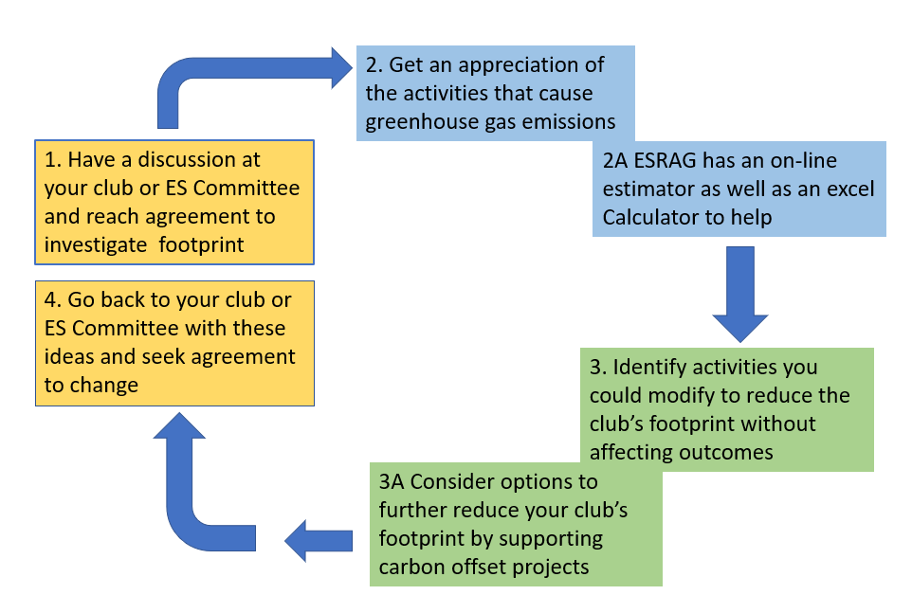
______________________________________________________________

Do your Club meetings cause any carbon emissions ?
The results of our recently developed ESRAG carbon calculator show that at a typical Rotary Club meal-based meeting results in around 5 kgs of carbon dioxide equivalent emission per member. This mainly results from travel, food and energy. So, for example with an average of 20 attendees per meeting, over a year, about 5 tonnes CO₂-e will result. Events and projects will also normally result in further carbon emissions.
[Note: CO₂-e: A carbon footprint is usually reported on the basis of greenhouse gas emissions equivalent to what it would be if it were carbon dioxide emissions, which is one of the most powerful and long-lived greenhouse gases in the atmosphere]
ESRAG Oceania have developed tools to assist you identify emissions from your club’s activities. This is shown on the following flow chart: -

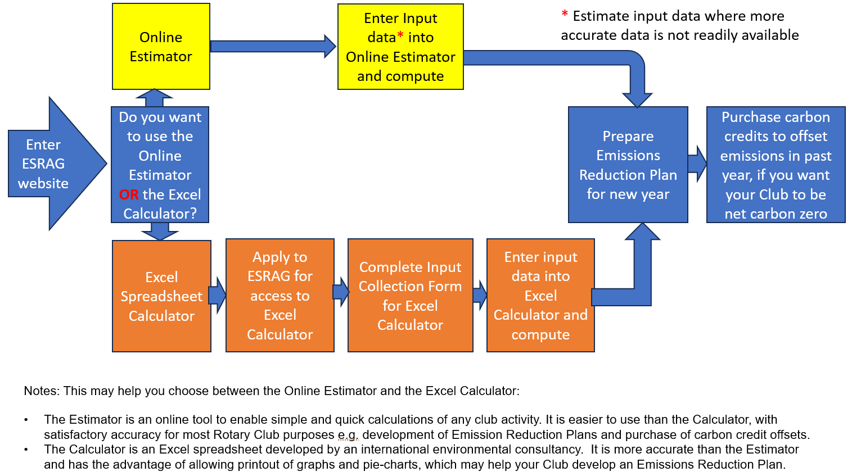
There are 2 options for Rotary Clubs in Australia, New Zealand and Europe to estimate or calculate your club’s Carbon Footprint:
The Rotary Club Online Carbon Estimator allows you to quickly and efficiently estimate your Club’s emissions for any meeting, event, or project. Just log on at: https://esragoceania.org/rotary-club-event-carbon-estimator/ and enter values for your Rotary Club meeting, event or project. It is simple to use. Estimate numbers attending; travel arrangements; and expected food and drink consumption; etc. The results will be emailed to your address. If you have multiple events the Estimator can be used several times. You can also use the Estimator to see how potential changes would affect the carbon footprint.
The Rotary Club Excel Carbon Calculator will take more time to use than the Estimator as it includes more detailed information and can incorporate all meetings, events or projects that may occur over a year. This calculator has been developed by an international environmental consultancy and can provide a more accurate calculation your club’s carbon footprint. With all activities on one spreadsheet printing of graphs or pie charts enables presentation to club members. A number of data collection forms are available on the website to get your calculation started. Request access to the excel spreadsheet calculator at: esragcalculator@gmail.com
______________________________________________________________

Take action
Prepare a Club Emissions Reduction Plan
A club emissions reduction plan can be prepared after looking carefully at modifying activities that cause emissions without affecting club outcomes. Examples of potential carbon reduction strategies for Clubs include: -
- Meals – consider reducing red meat meals as these have high emissions in their production - perhaps have more fish, chicken, or vegetarian meals (which have low emission levels). Introduce alternative meals or perhaps have fewer bar-b-ques.
- Transport – most members use their cars and currently most are likely to use petrol or diesel. Ask members to consider lower carbon intensity transport options such as public transport, sharing rides, using a bicycle, or walking to meetings. Provide information about the benefit of hybrid or electric vehicles for your members next car purchase.
- Meetings – consider having fewer face to face meetings, or increase the use of hybrid meetings allowing some to participate on-line, and allow speakers from other geographic areas to zoom in.
- Committee Meetings – do some meetings by zoom to reduce travel.
- Projects – for projects not in your immediate neighbourhood consider how to lessen the carbon footprint impact from travel. Reduce or avoid flights because air travel is the highest carbon emitting travel mode. Put more reliance on Rotary Clubs in the project area to lessen your need to travel.
- Power supply – firstly consider how you might reduce your requirements, change the temperature settings - just a 1ºC change will reduce your heating or cooling bill and reduce carbon emissions. As well as reducing your power use, see if it is possible to switch to an electricity supply with a higher proportion of renewables like hydro, wind or solar, rather than electricity generation from fossil fuels like coal or gas.
Prepare a Carbon Offset Plan for your Club
Even after your club has implemented an Emissions Reduction Plan your club activities are likely to still have a carbon footprint.
The club could consider offsetting emissions by purchasing a ‘carbon credit’ [Note: One carbon credit is equal to 1 tonne of CO2-e net abatement] or supporting a project with beneficial climate outcomes. Carbon credits are awarded to defined projects that store, avoid, or reduce greenhouse gases in the atmosphere. Examples are: -
- Store: These are usually land specifically set aside for reforestation projects with strict covenants to ensure the forest remains permanent and is not harvested. When it is regenerating native forest, there are biodiversity co-benefits through protection of endangered native bird species.
- Avoid: These are usually energy generation projects that use renewable energy, such as hydro, wind farms or solar panels, instead of fossil-fuels.
- Reduce: These are usually a form of technology that reduces emissions, for example efficient solar cook stoves that replace inefficient fossil-fuel burning stoves. There are many of these schemes in developing countries such as Timor Leste or Ethiopia, that have co - benefits of improved health and social development of local communities.
Carbon offsets can be arranged in a number of ways: -
Payment to a commercial offset plan:
- Commercial offset plans include Qantas, Greening Australia, Carbon Neutral, Green Fleet and no doubt others to be researched. The money goes into a pool for that organisation to put money into their carbon offset projects.
Payment to fully accredited programmes where carbon credits are issued:
- Commercial offset plans for specific purposes (e.g., reafforestation in South West Australia) with credits provided at A$31.50/t(CO₂-e) (2023 price).
- Carbon credits for regenerating native forests in New Zealand have increased in price in recent years to as much as NZ$100/t(CO2-e) (2023 price).
- Carbon credits that may align with a Rotary Club’s interests (e.g., withoneseed.org.au in Timor Leste sells credits for work in that country).
- In New Zealand, Toitū Envirocare provides advice on carbon credit registries that apply, from all over the world:
https://www.toitu.co.nz/what-we-offer/carbon-management/mitigate
Payment to an accredited ESRAG organised project:
- Include any ESRAG Promoted and Partnered offset program –– a project for Rotary Clubs to support (e.g., a Mangrove planting project with a commercial partner where carbon sequestration can be identified).
- An ESRAG offset program where money is collected and used to projects that have been accredited.
Non accredited programs where carbon sequestration is estimated:
- Rotary Clubs may not be looking for official carbon credits, and may wish to put their efforts, in-kind and funding, into supporting projects such as tree planting in rural and bushfire areas accepting an estimate of carbon sequestration.
- ESRAG offset programme when money is used for a Rotary Project. The estimated carbon reduction resulting from the programme would be reported.
_________________________________________________________________

